- Board the AT SkyRide Bus: Head to the airport bus gates (Gates 6–10 at the DEN Transit Center) and catch the AT Route bus heading toward Arapahoe at Village Center. [1, 2]
- Exit at Arapahoe at Village Center Station: Ride the bus directly down I-225 to the DTC area. [1, 2]
- Final Leg: From the station, the Marriott is roughly 1.5 miles north. You can grab a very inexpensive 5-minute rideshare (Uber/Lyft) for the final mile, or hop on an E-Line or R-Line light rail train heading north for one stop to Belleview Station.
The Denver Marriott Tech Center is located just 0.3 miles east of Belleview Station. It is a very flat, straightforward 7-minute walk. [1]

Step-by-Step Walking Route
- Exit the Station: Walk out of Belleview Station and head east on E Union Ave toward S Newport St.
- Cross the Street: Continue straight along E Union Ave for about two blocks, crossing under the highway overpass and passing S Niagara St.
- Turn Right: When you reach S Syracuse St, turn right (south).
- Arrive at the Hotel: The Denver Marriott Tech Center entrance will be immediately on your left at 4900 S Syracuse St. [1]

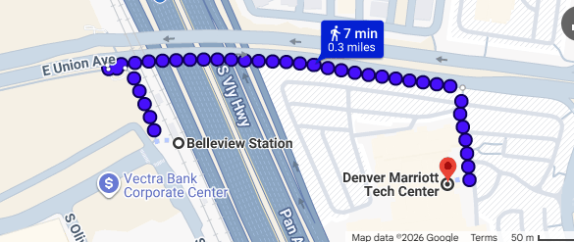

How to Buy Tickets
- Fare: $10.00 for an Airport Day Pass. This single ticket covers your train, bus, and any transfers for the entire day. (If you are 65 or older, you qualify for a Discount Fare of $1.35–$2.70).
- Where to buy: Download the RTD MyRide App on your phone to buy and activate the ticket before boarding. Alternatively, you can use credit/debit card contactless "Tap-n-Ride" directly at the platform validators, or buy a paper ticket at the airport station vending machines

